**AuthService**

[Automated Test_V1.0]

|  |  |  |  |
| --- | --- | --- | --- |
| **版本** | **作者** | **时间** | **修订描述** |
| V1.0 |  | 2022.06.08 | AuthService Automated Test |
|  |  |  |  |

Index

1. Automated Test Tool 3

1.1 UserCreate Test 4

1.2 RoleCreate Test 7

1.3 UserAddRole test 10

1.4 Authenticate test 10

1.5 RoleCheck test 11

2. Automated Test Report 12

## 1. Automated Test Tool

**Postman** lets you write scripts that run before/after you receive a response from the server. You can do practically anything in these scripts.

First, create a collection, and prepare some auto test scripts a like below:

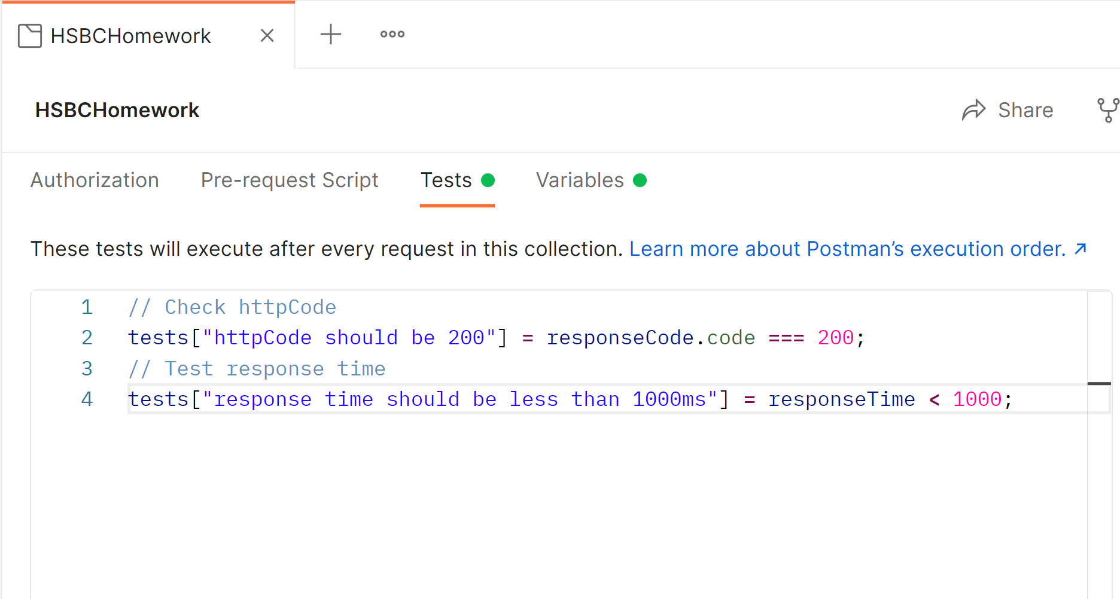

**In the script we test reponseCode and responseTime, these are for all APIs. We also set variable, which is user auth token, because when created, it will be used by the nest API calls.**

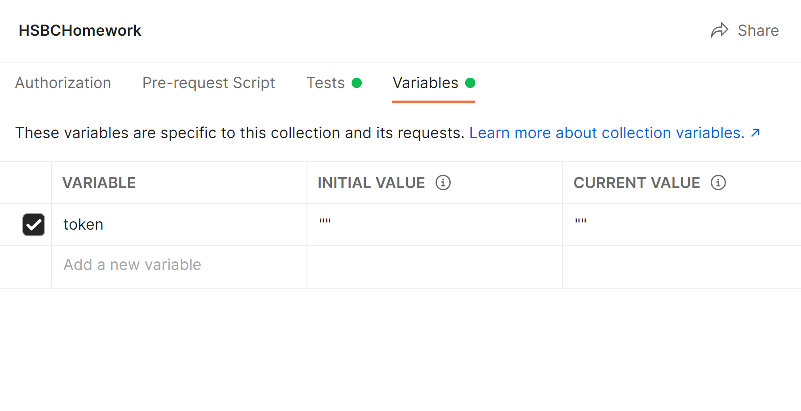

## UserCreate Test

There are 3 cases:

200, success

201, params error

202, user already exist

So we create 3 API calls, set request params accordingly.

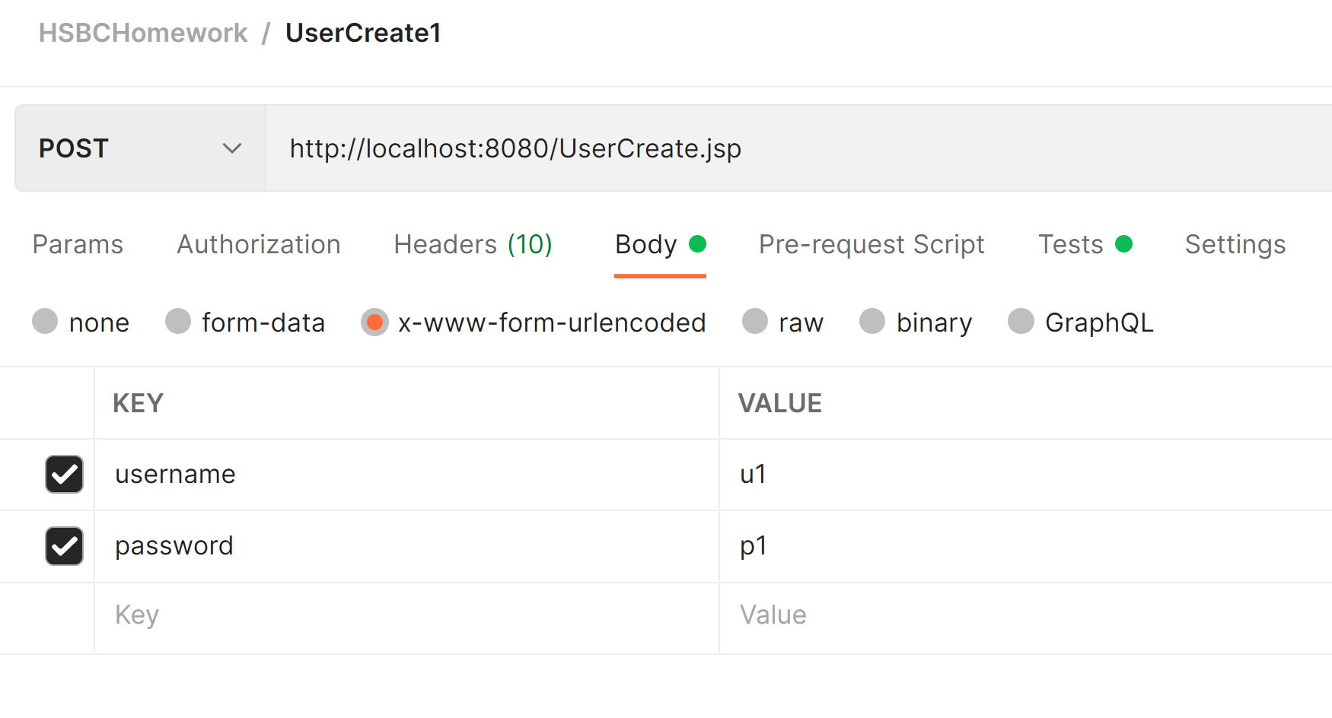

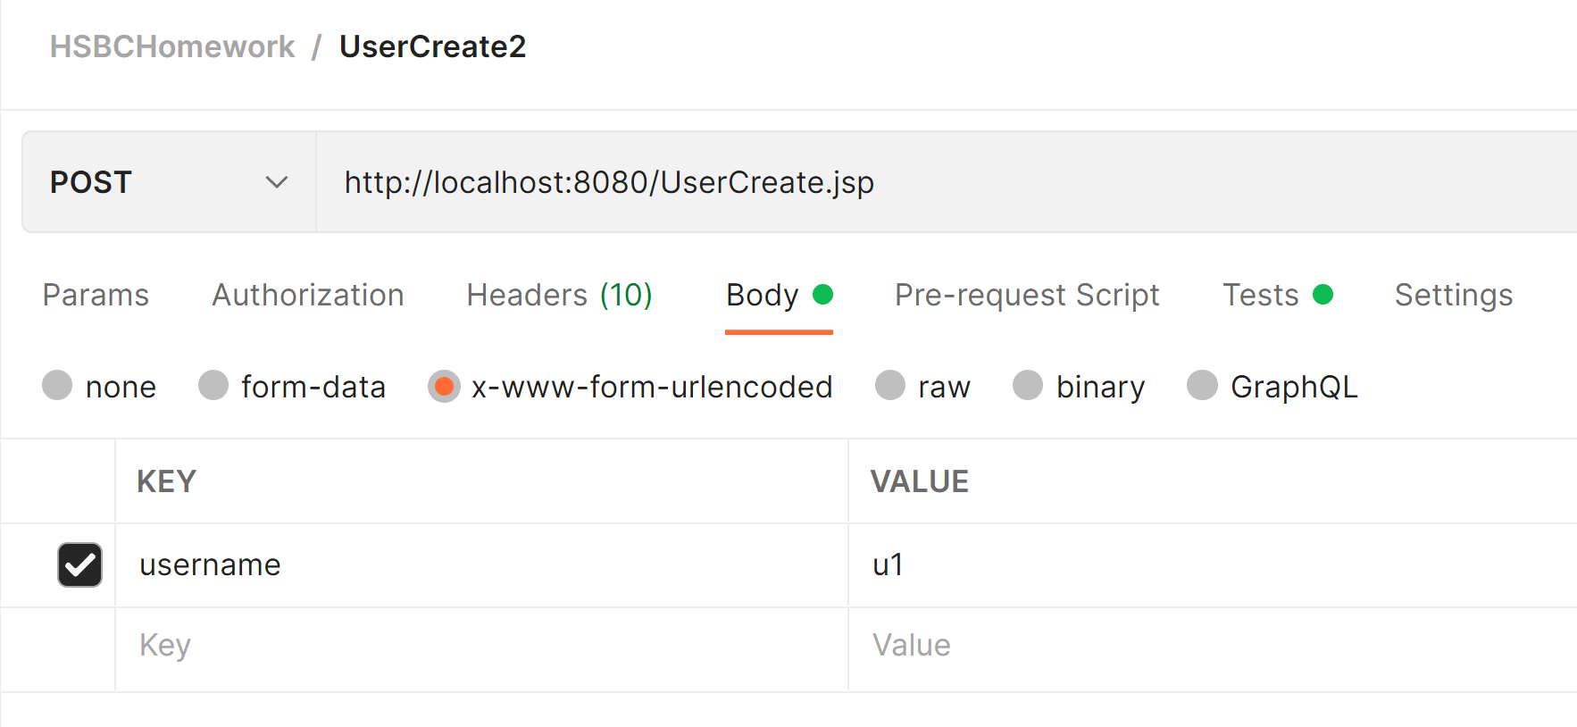

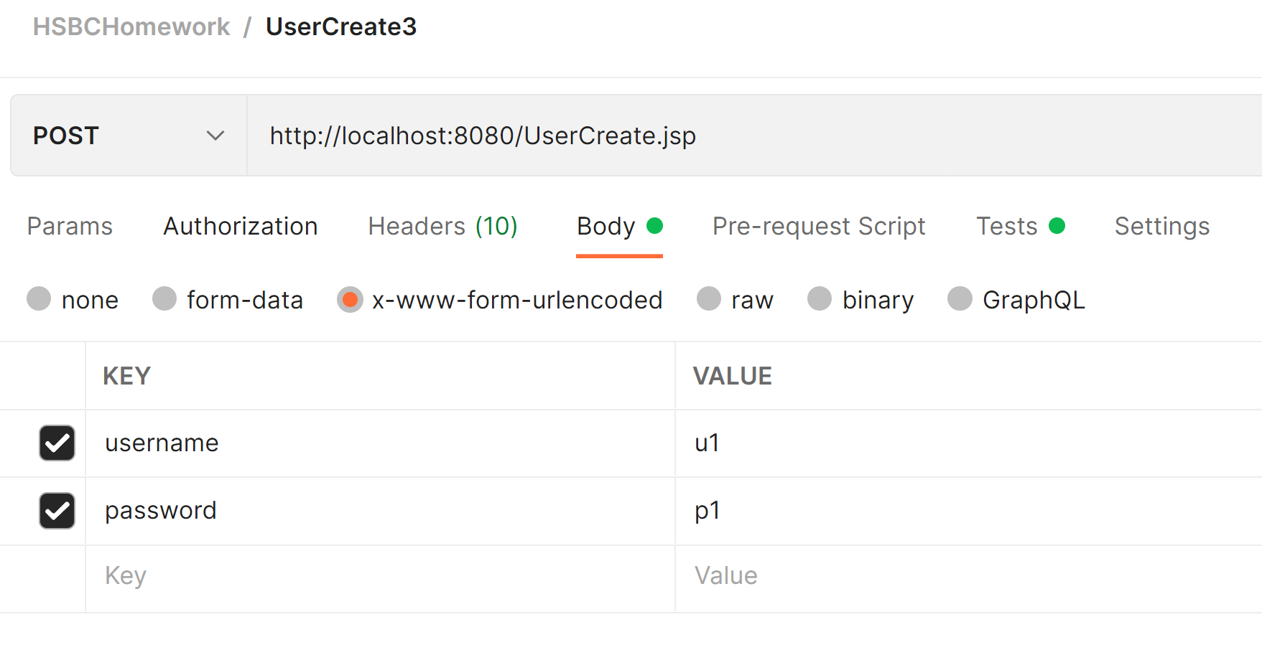

Test result:

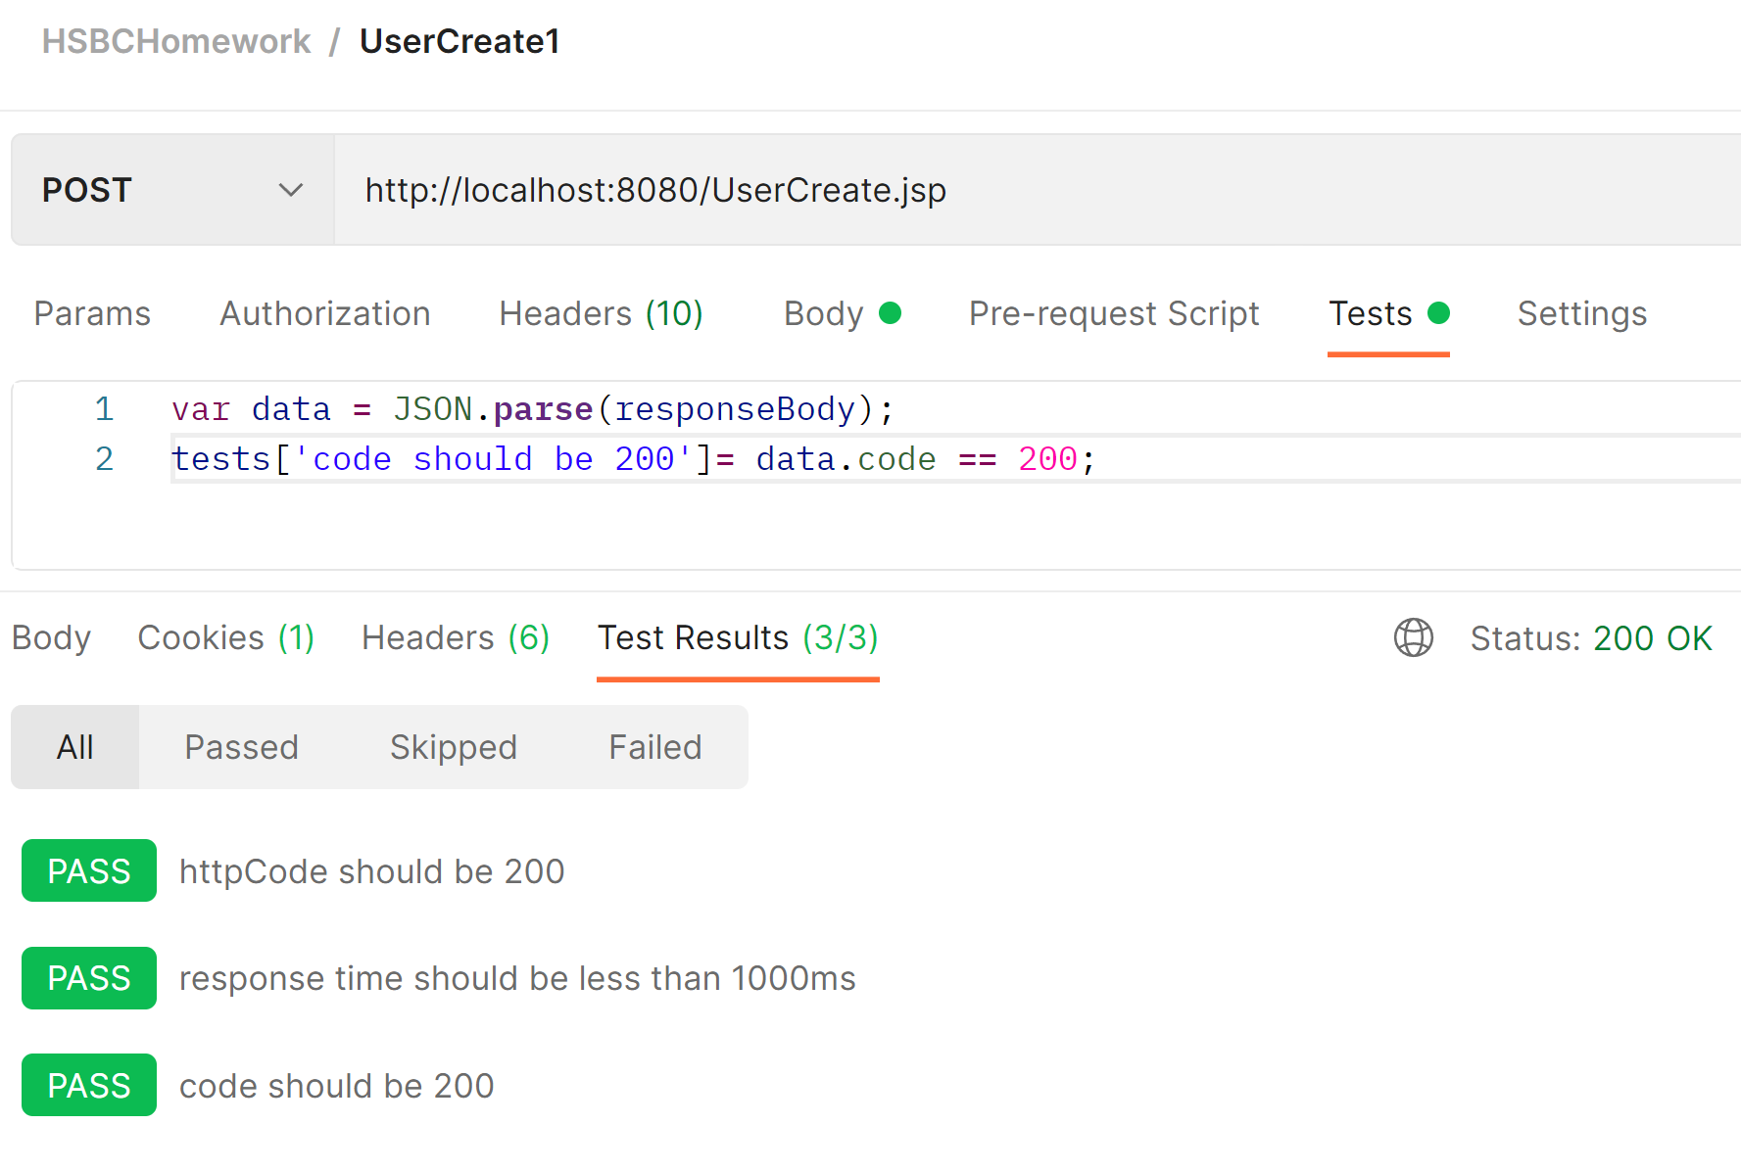

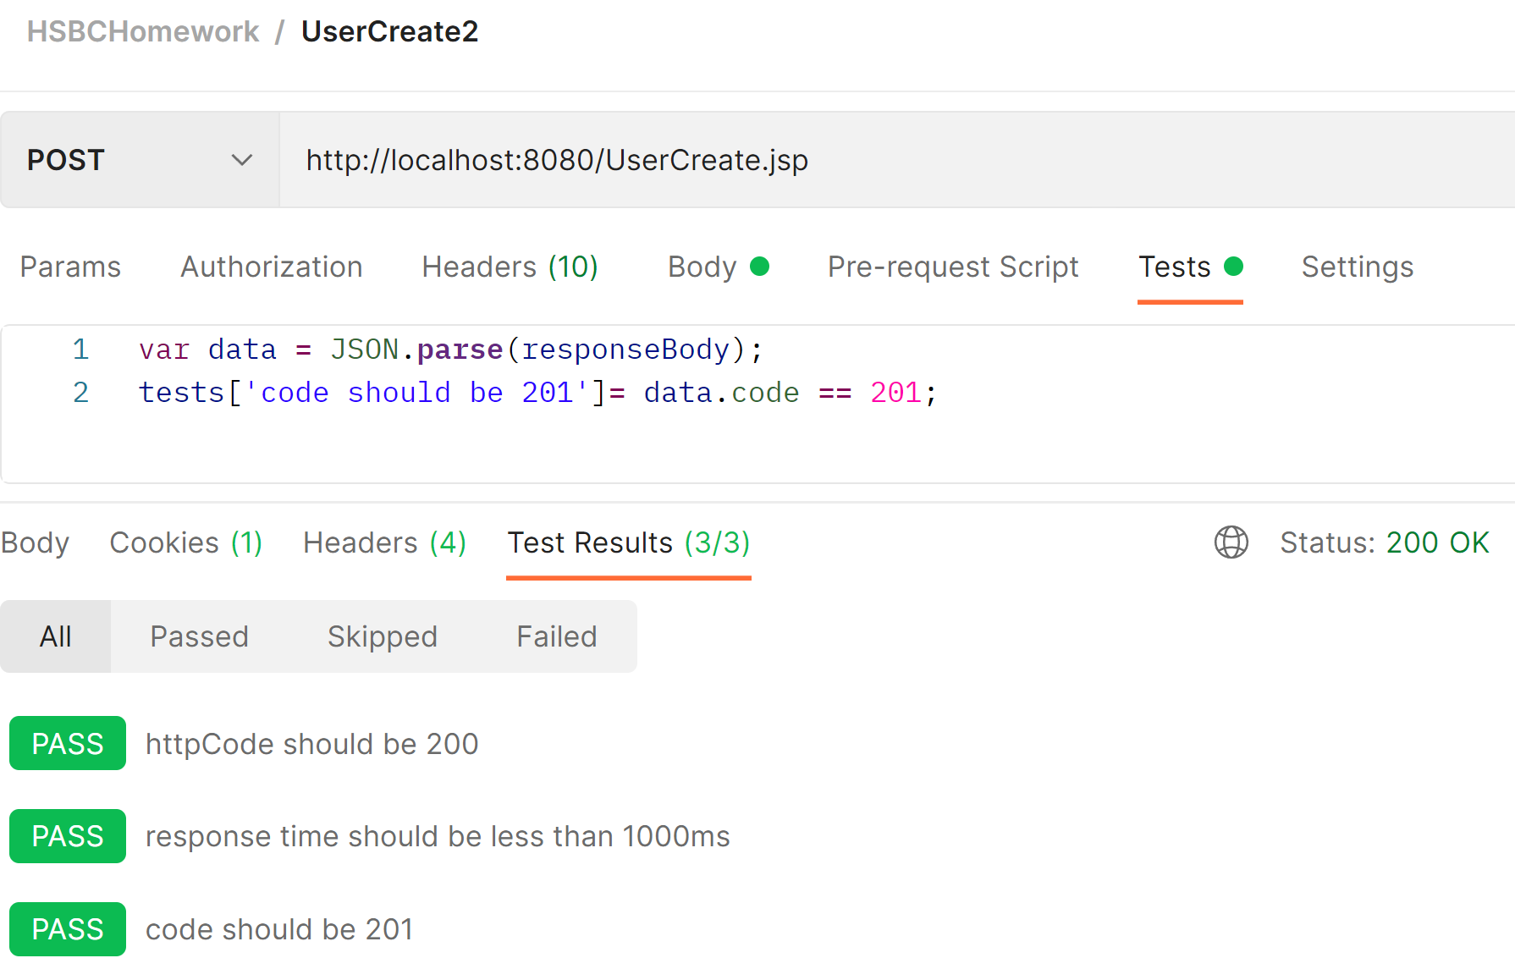

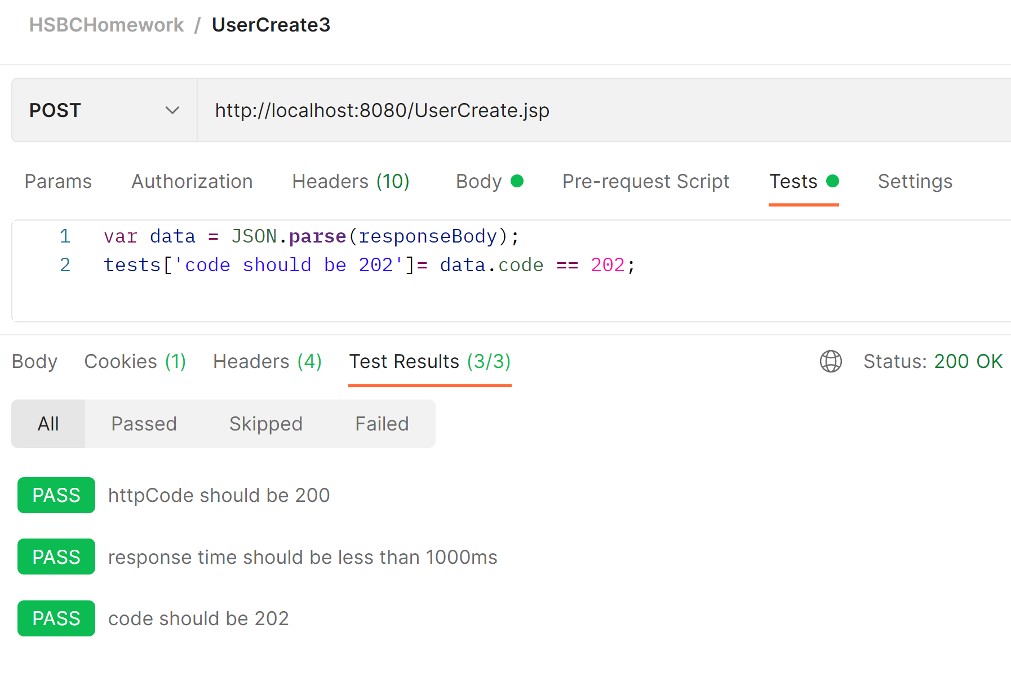

## RoleCreate Test

There are 3 cases:

200, success

201, params error

302, role already exist

So we create 3 API calls, set request params accordingly.

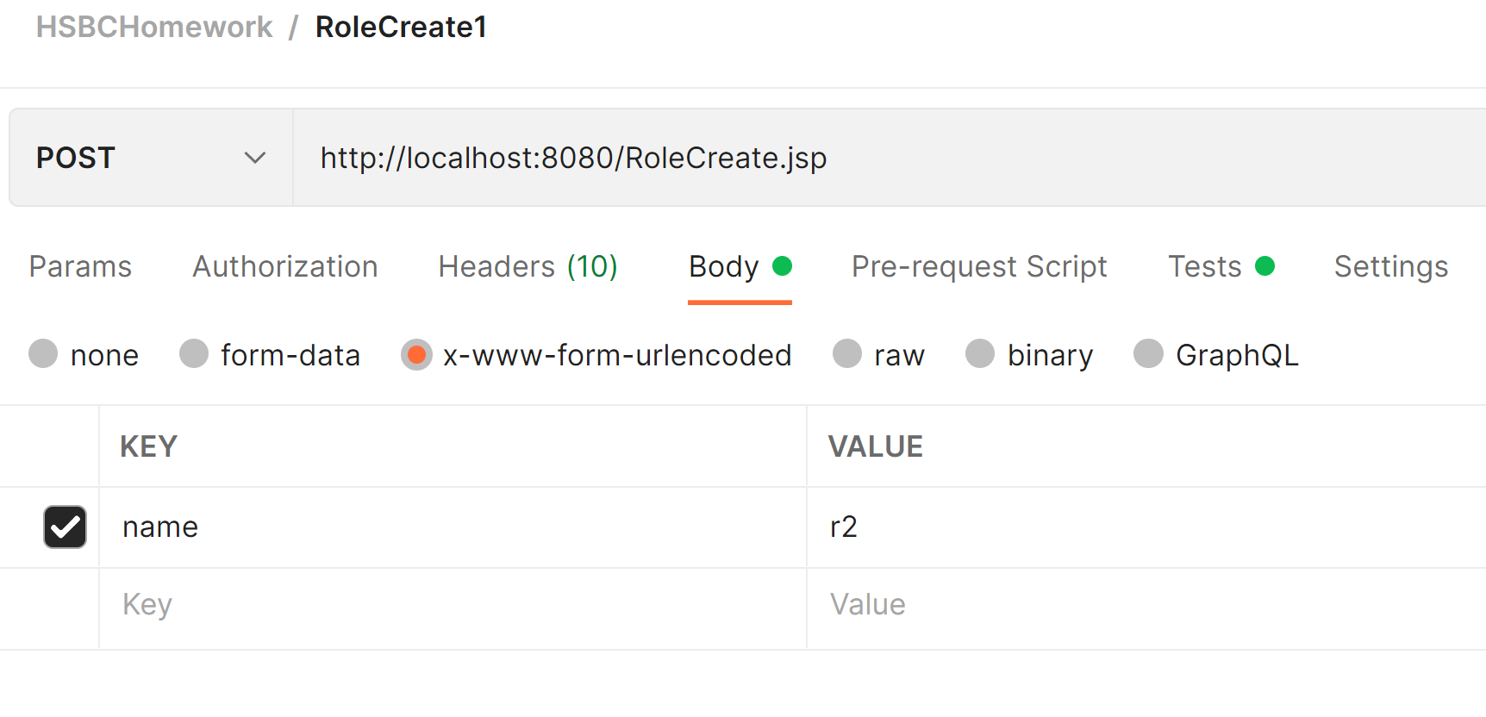

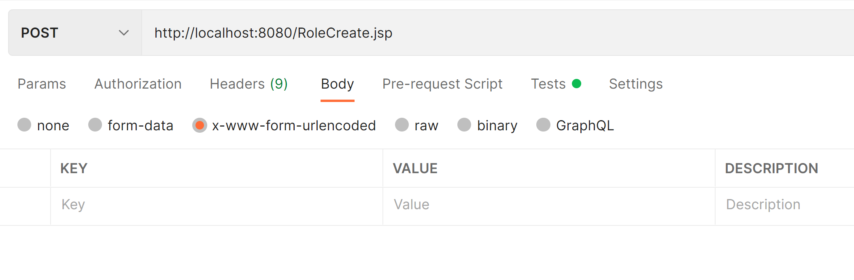

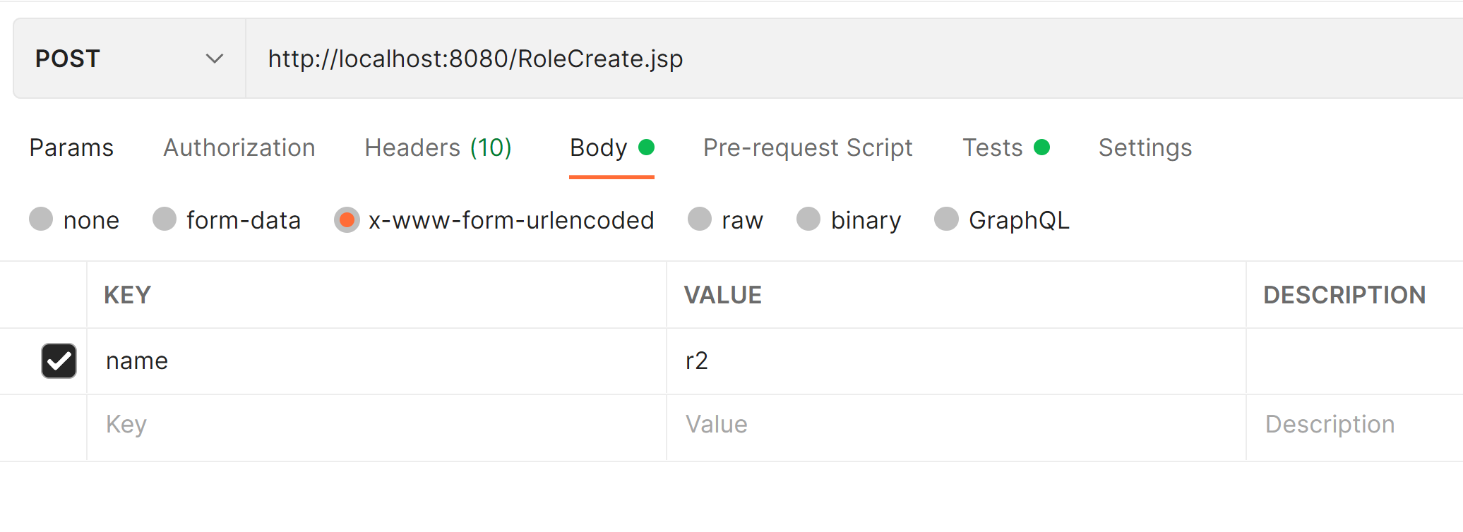

Test result:

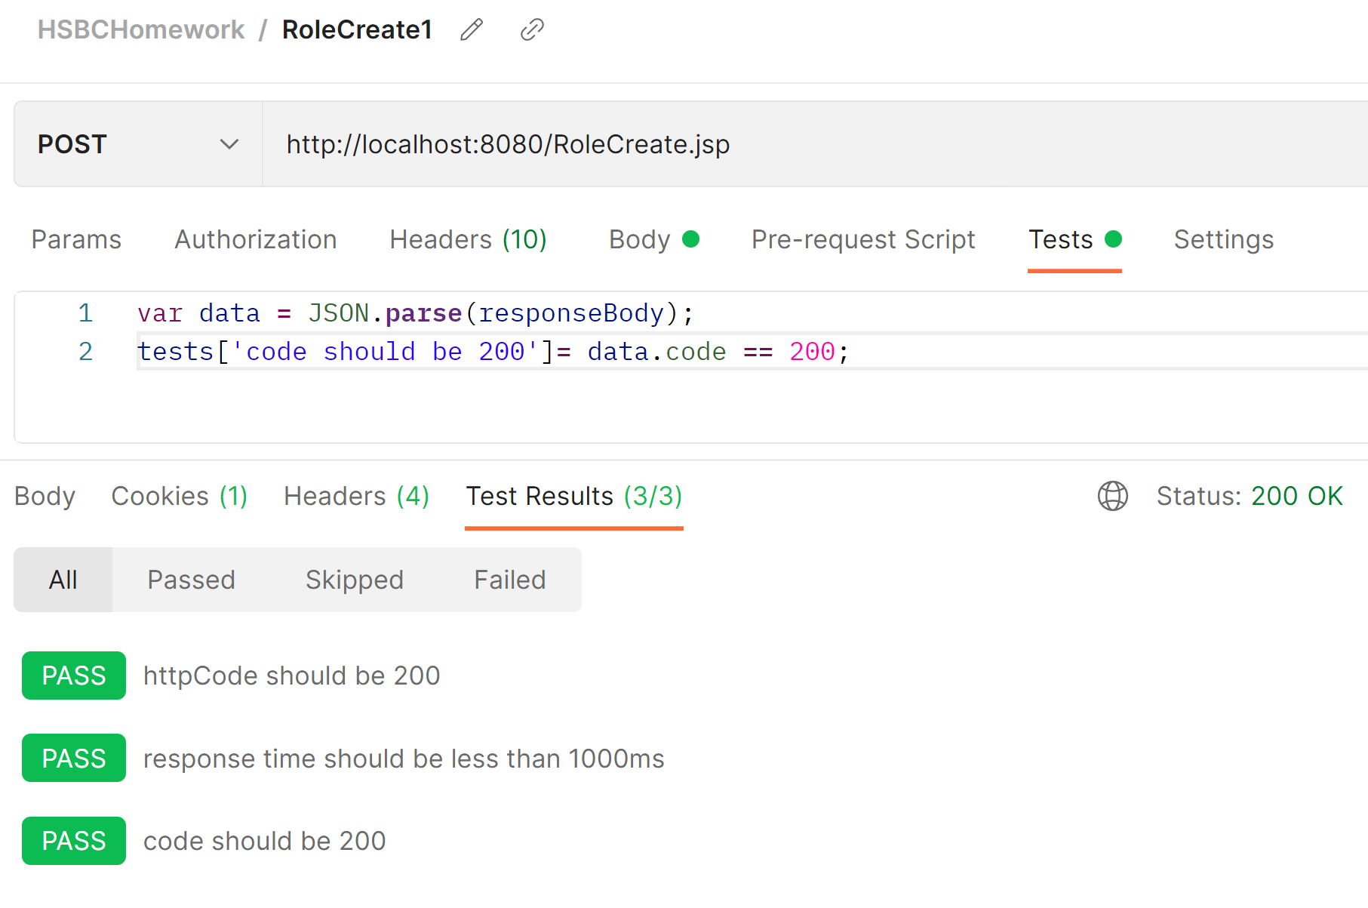

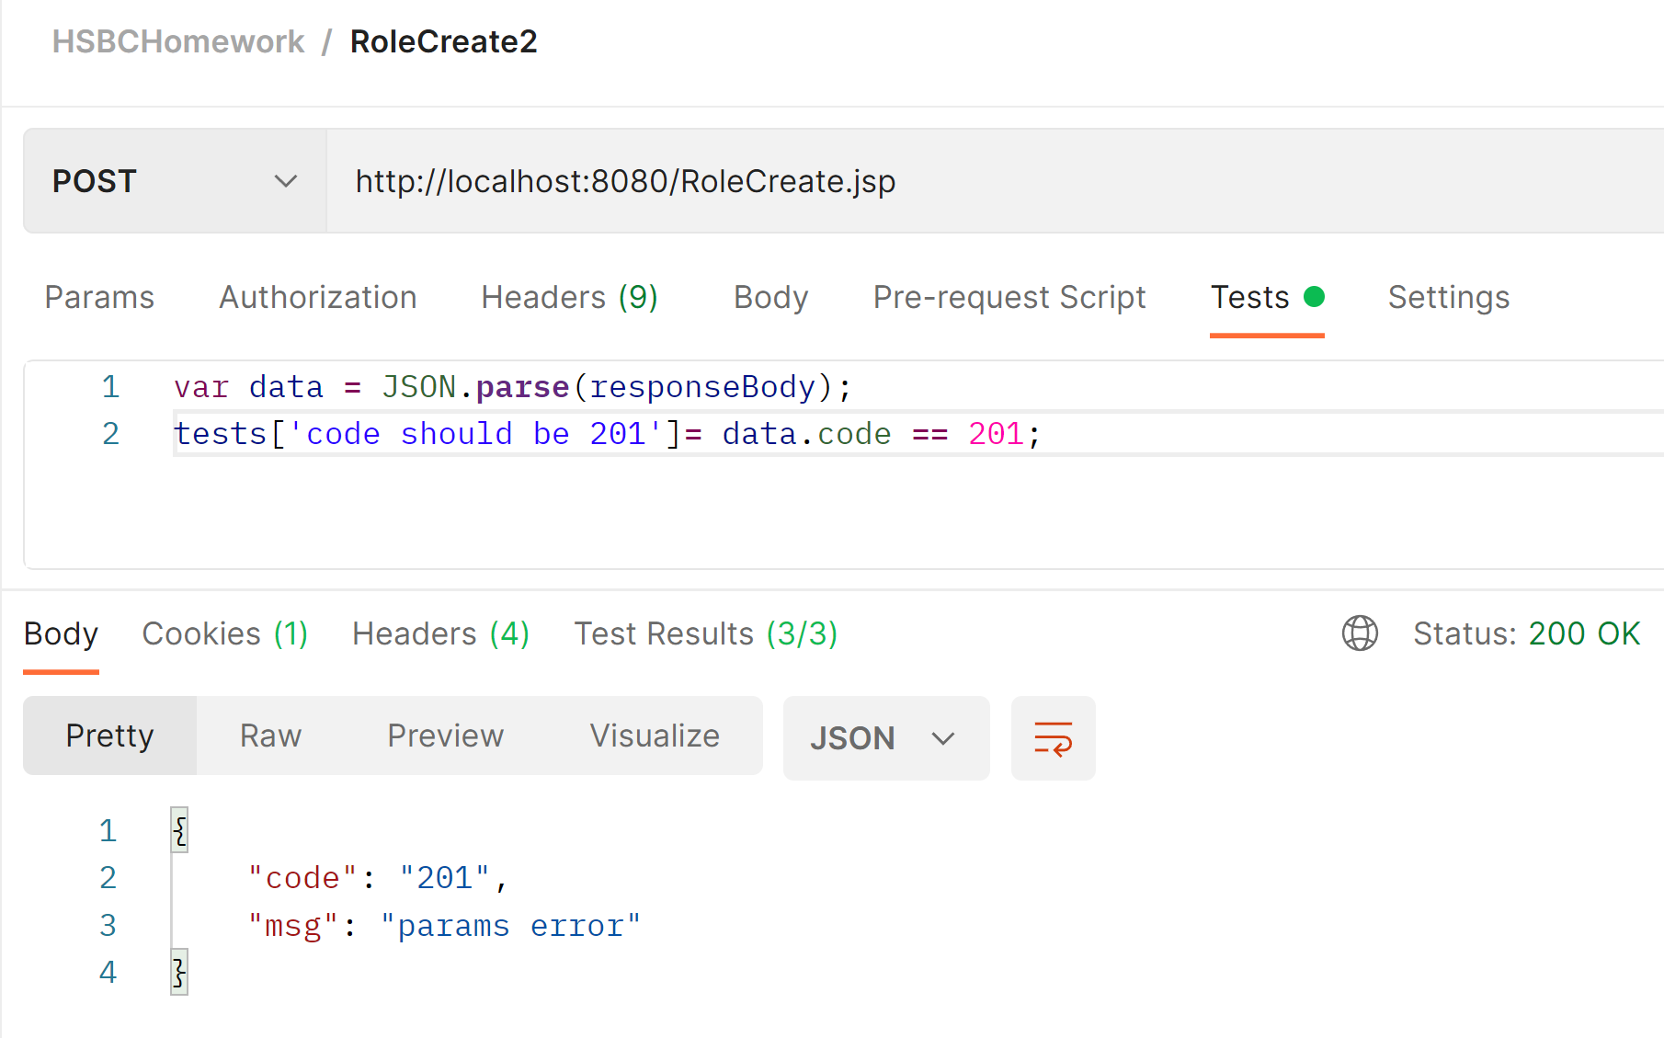

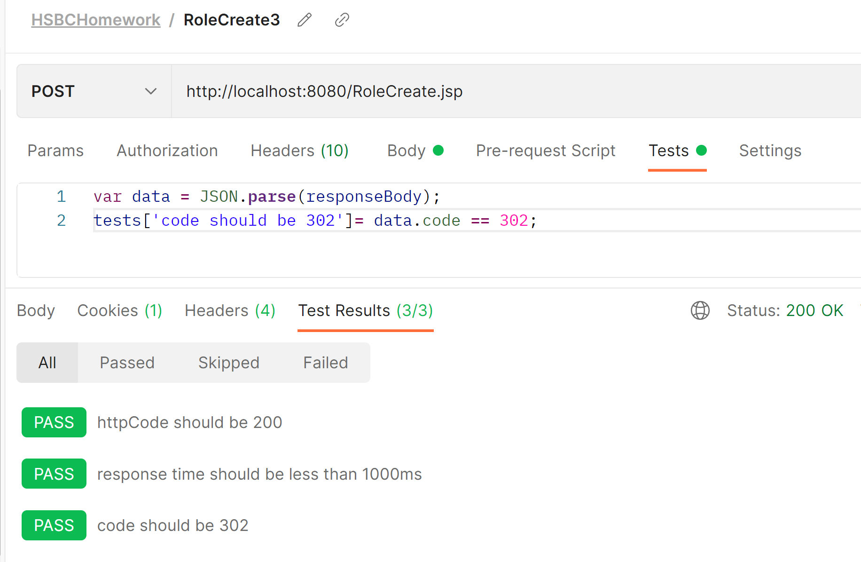

## UserAddRole test

There are 6 cases:

200, success

201, params error

203, users empty

204, user not exist

303, roles empty

304, role not exist

## Authenticate test

There are 5 cases:

200, success

201, params error

203, users empty

204, user not exist

205, password incorrect

## RoleCheck test

There are 6 cases:

200, success

201, params error

203, users empty

204, user not exist

402, invalid token

403, token expired

Then in Authenticate API, we can set the token value after successful calling.

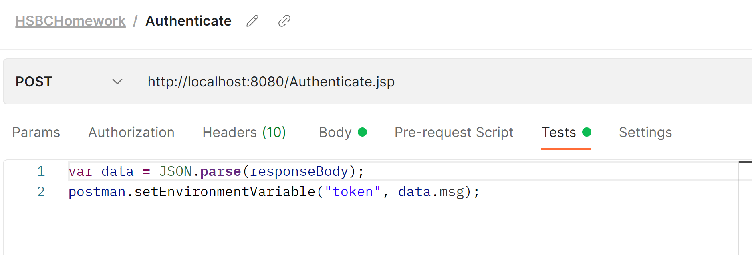

In RoleCheck API, we can use another script to test the token expiration after 2 hours.

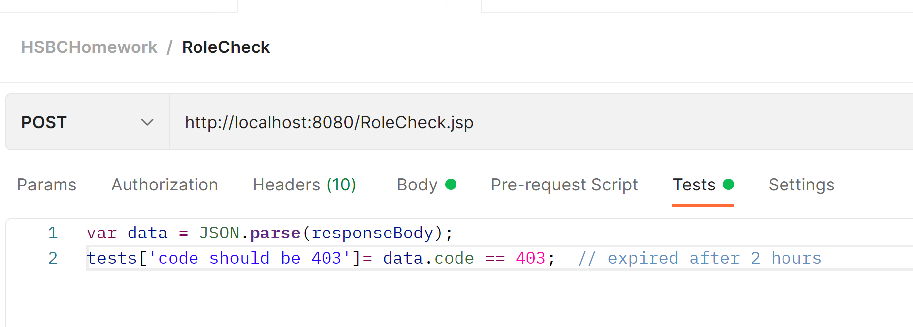

## 2. Automated Test Report

First, create automate test by clicking Runner:

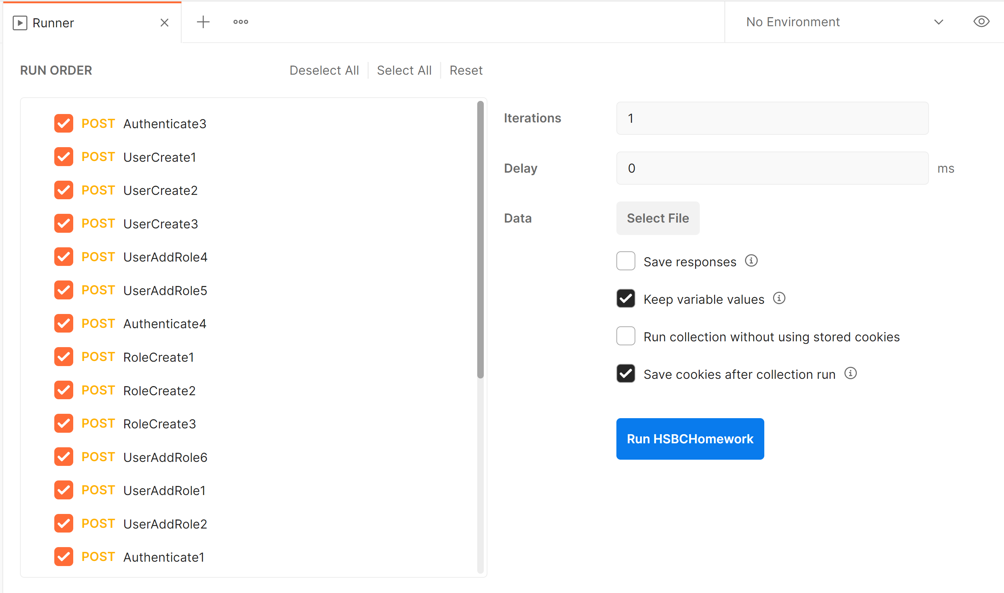

Then the report will be generated:

